Graphic Processing



**Project Documentation**

Moldovan Ștefana-Maria

Group 30434

3rd year

Computer Science

**Assistant Teacher:** Alexandru Horea Anisorac

Table of Contents

1. Subject specification **3**

2. Scenario **3**

a. Scene and object description 3

b. Functionalities 5

3. Implementation details **6**

a. Functions and special algorithms………………………………………………………………………………..6

i. Possible solutions................................................................................................6

ii. The motivation of the chosen approach............................................................6

b. Graphics model...............................................................................................................6

c. Data structures................................................................................................................7

d. Class hierarchy................................................................................................................7

4. User manual................................................................................................................................7

5. Conclusions and further developments......................................................................................8

6. References..................................................................................................................................9

1. **Subject specification**

The subject of this project is the photorealistic presentation of 3D objects using OpenGL library. Open Graphics Library is a specification of a standard which defines a multiplatform API, widely used for programming the 2D and 3D components of computer programs.

The scene I chose to implement is a small medieval kingdom, that has a fortress, knights, dragons and other beings. The user manipulates the object scene directly by entering the mouse and keyboard and can move around it.

1. **Scenario**

**a. Scene and object description**

The scene showcases a small medieval fortress with two dragons and a group of knights approaching on a road, appearing ready for an attack. Inside the fortress, there's a king, an elf lady, and several buildings, guarded by additional knights. The broader map also features nature elements, including a deer.

Here are some illustrations with the scene:

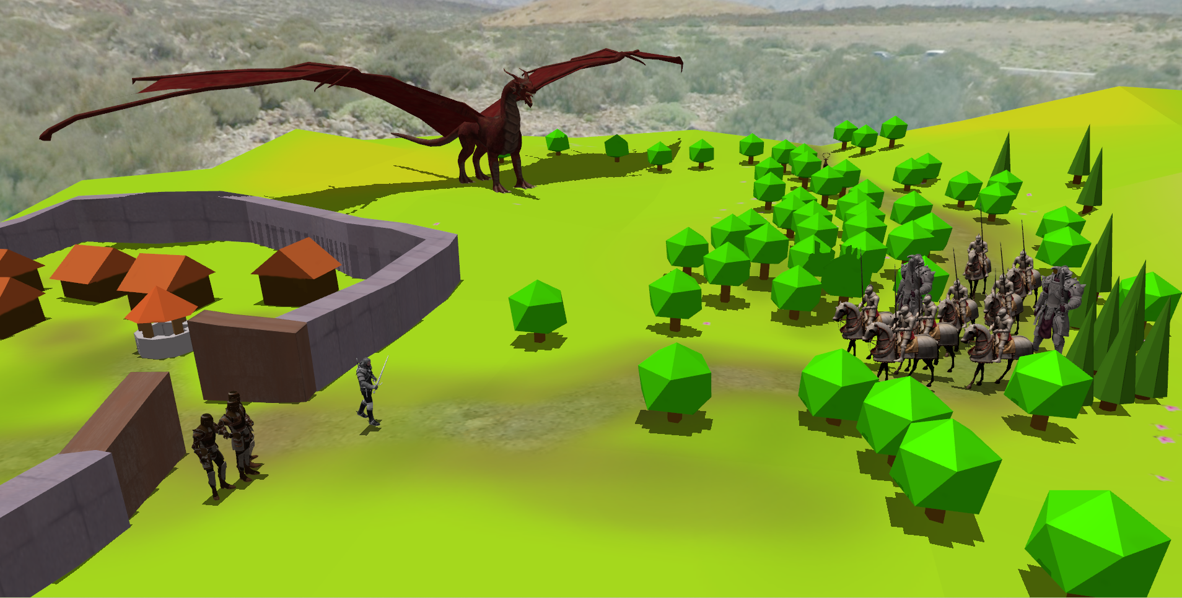

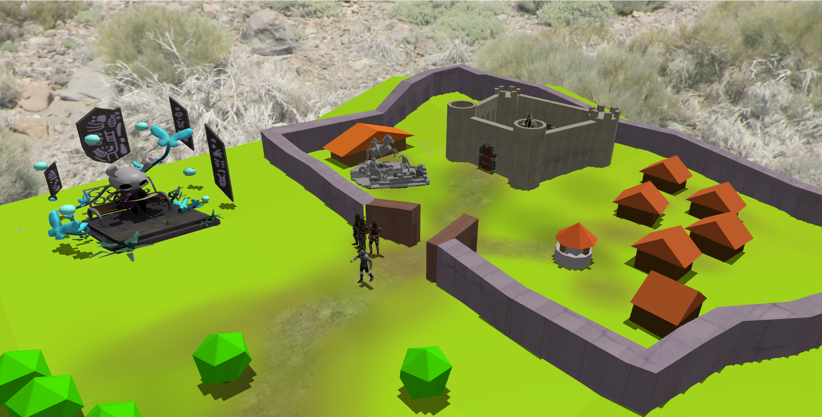

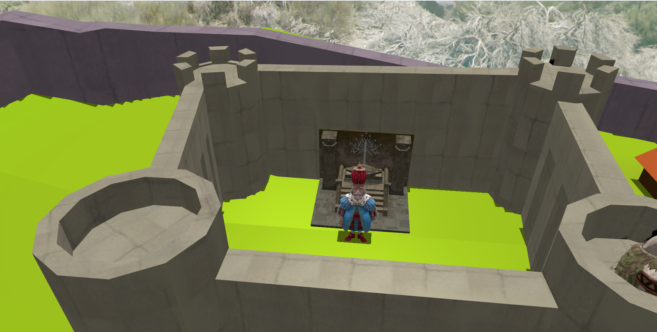

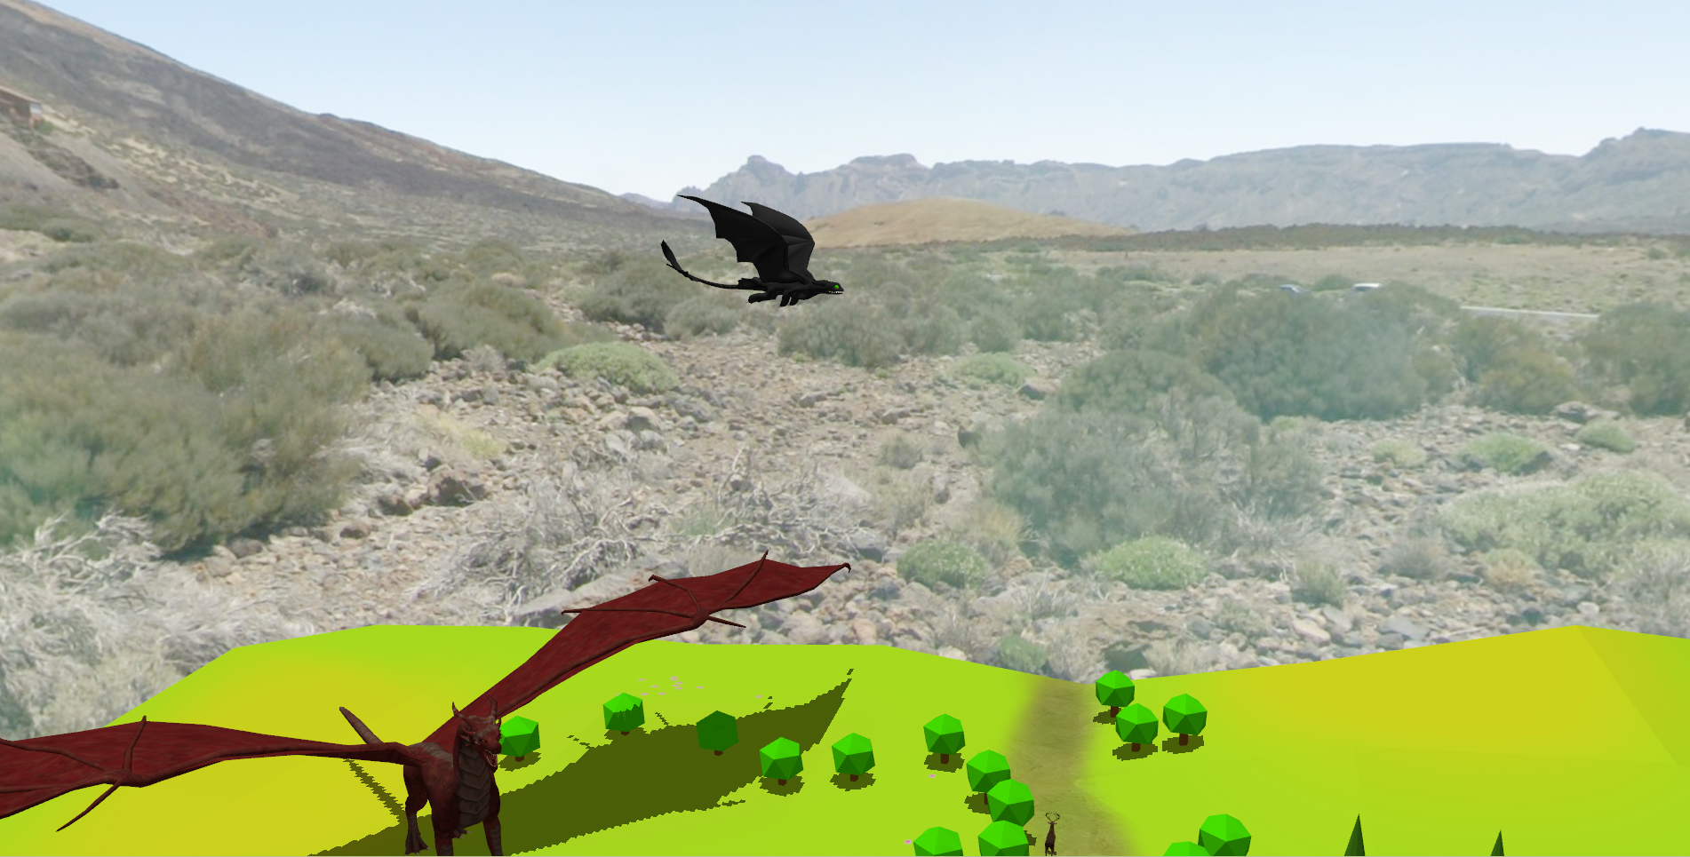

**b. Functionalities**

The user can have a visualization of the entire scene by pressing the keyboard keys or the mouse. One can also switch between solid view and wireframe or polygonal and smooth face using keyboard keys. Fog also appears or disappear by the choice of the user. Its intensity can be increased or decreased.

There are multiple sources of light: directional light, the point light. Also the object that projects the point light can be moved by pressing the corresponding keyboards.

1. **Implementation details**

**a. Functions and special algorithms**

**i. Possible solutions**

OpenGL library consists in a large variety of functions such as:

* glViewport(…) used for setting Viewport transform
* glfwCreateWindow(…) used for creating the window
* glGenTextures(…)
* glBindTexture(…)
* glTextImage2D(…) used for creating depth texture for the Framebuffer objects
* many others.

One of the functions I’ve used in this project is void renderScene() which is the function used to send all the data to the shaders and compute all the values. Here is where all the models and their shadows are created, where the normal matrix are computed and where the rotation, translation and scaling are done.

Another function is void initUniforms(), where the lights’ details are all set – the point light, the directional light and the spotlight.

The function void initShaders() is a function where the shaders are instantiated.

The function void initModels() is a function where all the 3D Models are instantiated.

Another important functions are:

* void processMovement()
* void move(gps::MOVE_DIRECTION direction, float speed)
* void mouseCallback(GLFWwindow* window, double xpos, double ypos)
* void keyboardCallback(GLFWwindow* window, int key, int scancode, int action, int mode)

These functions perform all the necessary changes on the models or on the camera so that they perform the moves desired by the user.

**ii. The motivation of the chosen approach**

In the laboratories dedicated to this subject we have learnt how to compute light, shadows, to perform operations of translation, scaling and rotation on different objects. Having this starting point and also a skeleton of the project, the work I had to do in carrying out this project had a fairly well-defined path.

b**. Graphics model**

Objects and textures have been downloaded from the internet. Most objects were imported into the Blender to be edited and placed in the final scene.

This part seemed to me quite difficult, because some textures were not displayed on the object or, moreover, the object was not displayed. Therefore, I had a longer search for objects/textures.

However, I consider this to be the creative and enjoyable part.

**c. Data structures**

The only data structures required were some simple ones, to hold together all the attributes of the different types of light, as for spot light and point light. They have already been implemented in the project provided to the laboratory, so it was quite useful to have it. In addition, I added some functions to calculate the lights and fog.

**d. Class hierarchy**

* Camera: contains the implementation for camera movement (up, down, front, back, left, right)
* SkyBox: contains skybox implementation (load, draw, load textures, initialize)
* Mesh: represents a 3D object; includes the following data structures:
* Vertex (position, normal vector and texture coordinates)
* Texture (id, type and path); Material
* Model3D: contains methods for printing meshes using a specified shader program
* Shader: contains methods for creating and activating shader programs

1. **User manual**

The user can interact with the scene using the following keys on the keyboard:

* I - start the preview of the scene
* U - stop the preview
* V and B - move the light cube
* F - modify intensity of the fog
* K - show wireframe view
* L - show solid view
* M - show point view
* Q - rotate camera to left
* E - rotate camera to right
* W - move camera to the front
* S - move camera backwards
* A - move camera to left
* D - move camera to right

1. **Conclusions and further developments**

This project successfully achieved the goal of implementing a photorealistic 3D scene using the OpenGL library. The medieval kingdom scene, featuring a fortress, dragons, and knights, allows users to navigate and interact with the environment using mouse and keyboard inputs.

Throughout development, the project underwent iterative adjustments to OpenGL functions, algorithms, and scene features. Rigorous testing ensured the effective implementation of fog, dynamic lighting, and object manipulation.

The project's practical utility lies in providing users with an engaging 3D experience. Features like view switching, lighting control, and scene navigation enhance user interaction and immersion.

Future improvements could focus on enhancing graphic models with higher-quality textures and objects. Optimizations in data structures and class hierarchies may also be explored for increased efficiency. The user manual serves as a comprehensive guide for user-friendly interaction.

1. **References**

* Course: Graphic Processing, Fall 2020 (utcluj.ro)
* https://learnopengl.com
* YouTube
* <http://www.opengl-tutorial.org/>
* <http://tf3dm.com/>
* <https://free3d.com>
* <https://turbosquid.com>
* https://sketchfab.com/